Robert E. Wills Elementary School
First Grade Suggested Supply List 2016 – 2017

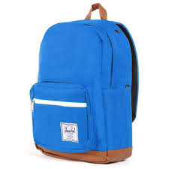  1 Backpack  No Wheels Permitted | 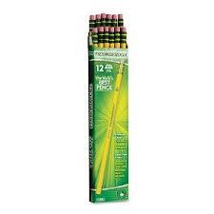  2 Packs #2 Pencils  Ticonderoga Preferred | 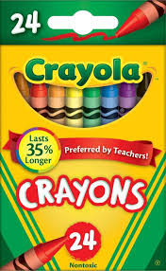  2 Boxes Crayons | 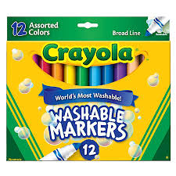  1 Pk Washable Markers
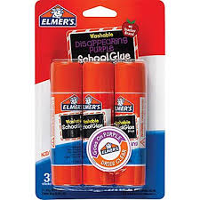  10 Glue Sticks or  5 Jumbo Glue Sticks | 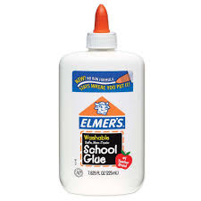  1 Bottle of Elmer’s Glue | 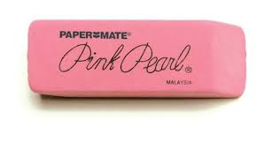  2 Wedge Erasers | 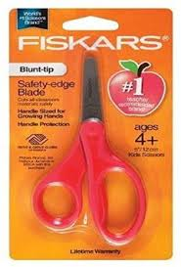  1 Pair Scissors  Blunt Tip
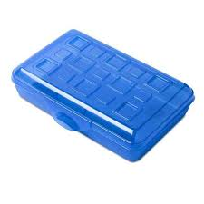  1 Plastic Pencil Box | 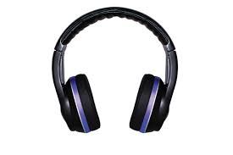1 Pair Headphones  No Ear Buds, Please | 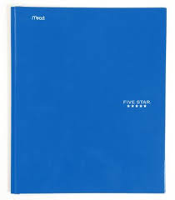  2 Sturdy Mead Pocket Folders  Green & Blue | 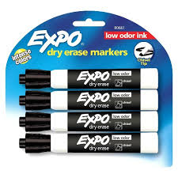  1 Pk Thick Black Expo Dry Erase Markers
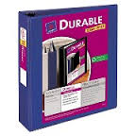  2 1” 3-Ring Avery Durable Clear View Binder | 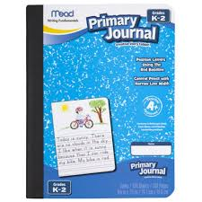  3 Primary Lined Composition Journals | 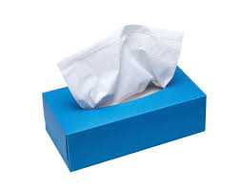  2 Boxes of Tissues | 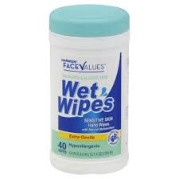  2 Wet Wipes
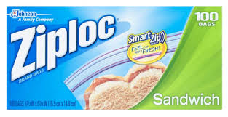  1 Box Ziploc Sandwich Size Bags  Boys Only | 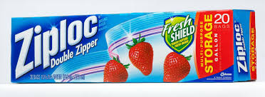  1 Box Ziploc Gallon Size Bags  Girls Only | 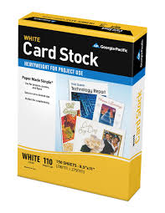  1 Ream of White Cardstock Paper  Boys Only | 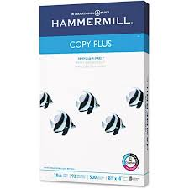  1 Ream of White Copy Paper  Girls Only

